

**Enterprise Travel & Expense Management System**

████████████████

Comprehensive Enterprise-Grade MERN Application

*by Kush Varshney*

*kushvarshney708@gmail.com*

Contact: [🗃️ GitHub](https://github.com/Kush-Varshney/) [👥 LinkedIn](https://www.linkedin.com/in/kush-varshney-490baa250/) 📂 [Project Repository](https://github.com/Kush-Varshney/Enterprise-Travel-Expense-System)

**Table of Contents**

**1. Executive Summary**

**2. Business Impact**

**3. Project Overview**

**4. Problem Statement & Solution**

**5. Key Features**

**6. Tech Stack**

**7. System Architecture**

**8. User Journey**

**9. How to Use This System**

**10. Security & Compliance**

**11. Deployment & Environment**

**12. UI/UX & Screenshots**

**13. Challenges & Learnings**

**14. Future Improvements**

**15. Conclusion**

**16. Contact & Support**

________________________________________________________________________________

# Executive Summary

This document provides a detailed, professional overview of the Enterprise Travel & Expense Management System. The system is designed to automate, secure, and streamline travel and expense processes for modern enterprises, featuring multi-level approvals, robust security, real-time notifications, and a professional, responsive UI. This documentation is intended for recruiters, technical evaluators, and enterprise decision-makers.

# Business Impact

The system reduces manual errors, increases compliance, and accelerates approval cycles. It empowers HR, finance, and management teams to make data-driven decisions, ensures auditability, and enhances employee satisfaction through transparency and efficiency. By digitizing workflows, organizations can save time, reduce costs, and improve policy adherence.

# Project Overview

The Enterprise Travel & Expense Management System is a full-stack web application built with the MERN stack. It enables organizations to manage travel requests and expense claims efficiently, supporting multi-level approvals, role-based dashboards, audit logging, and real-time/email notifications. The system is designed for scalability, security, and ease of use.

Target Users: Employees, Managers, Admins, and Super Admins in medium to large enterprises.

# Problem Statement & Solution

Manual travel and expense management is error-prone, time-consuming, and lacks transparency. This system digitizes the entire workflow, providing secure, role-based access, automated multi-level approvals, real-time and email notifications, audit logs, and a modern, responsive UI. It ensures compliance, reduces fraud, and improves user experience.

# Key Features

The system offers a comprehensive set of features to address the needs of modern enterprises:

* Secure Login & Authentication: JWT-based authentication, bcrypt password hashing, rate limiting, and security headers.
* Role-Based Access: Employee (submit/view requests), Manager (approve/reject team requests), Admin (manage users, requests, audit logs), Super Admin (full privileges, user role management).
* Multi-Level Approval Workflow: Requests are routed through Manager, Admin, and Super Admin as per business logic.
* Real-Time & Email Notifications: Socket.IO for instant alerts, Nodemailer for email updates.
* Audit Logs: Comprehensive tracking of all actions, with advanced filtering.
* Expense & Travel Request Forms: Validations, file attachments, and business rule enforcement.
* CSV Export: Export filtered or complete data for reporting.
* Mobile Responsiveness & Dark Mode: Modern, accessible UI with dark mode toggle.
* Password reset, user activation/deactivation, attachment support, and more.

# Tech Stack

The system leverages modern, industry-standard technologies:

* React.js: Frontend library for building fast, interactive UIs.
* Tailwind CSS: Utility-first CSS framework for rapid, responsive design.
* Axios: Promise-based HTTP client for API requests.
* React Toastify: Elegant toast notifications for user feedback.
* Socket.IO Client: Real-time communication for notifications.
* Node.js: JavaScript runtime for scalable backend services.
* Express.js: Minimalist web framework for building REST APIs.
* MongoDB: NoSQL database for flexible, scalable data storage.
* Mongoose: ODM for MongoDB, enabling schema-based data modeling.
* JWT: Secure token-based authentication.
* bcrypt: Password hashing for security.
* Nodemailer: Email sending for notifications and password resets.
* Helmet: Security middleware for HTTP headers.
* Multer: File upload handling for attachments.
* json2csv: CSV export for reporting.
* dayjs: Date handling and formatting.
* Express Rate Limit: Prevents brute-force attacks and abuse.

# System Architecture

The project is organized into clear, maintainable modules:

Enterprise-Travel-Expense-System/  
├── client/ # React frontend  
├── server/ # Node/Express backend  
├── screenshots/ # UI screenshots

Key API Endpoints:

|  |  |  |
| --- | --- | --- |
| Method | Endpoint | Description |
| POST | /api/auth/register | Register a new user (validates input, sends welcome email, awaits admin approval). |
| POST | /api/auth/login | Authenticate user and return JWT token. |
| POST | /api/travel | Create a new travel request (with validation and document upload). |
| GET | /api/travel | List travel requests (filtered by role and status). |
| PATCH | /api/travel/:id/status | Approve or reject a travel request (role-based logic). |
| POST | /api/expense | Submit a new expense claim (linked to travel request). |
| PATCH | /api/expense/:id/status | Approve or reject an expense claim. |
| GET | /api/notifications | Fetch all notifications for the logged-in user. |
| GET | /api/users/audit-log | Retrieve audit logs for admin review. |
| GET | /api/travel/export | Export travel requests as CSV for reporting. |

# User Journey

A typical employee logs in, submits a travel request with supporting documents, and tracks its approval status. Managers receive notifications for pending approvals, review requests, and provide feedback or decisions. Admins oversee all requests, manage users, and ensure compliance through audit logs. Super Admins have full control, including role management and system configuration. The process is transparent, with real-time updates and a clear audit trail.

# How to Use This System

Instructions for each user role:

**Employee:**

* Register or log in to your account.
* Submit travel requests and expense claims with required details and documents.
* Track the status of your requests and receive notifications.
* Update your profile and manage your password.

**Manager:**

* Review and approve/reject requests from your team.
* Provide feedback or request additional information.
* Monitor team activity and compliance.

**Admin:**

* Manage all users, requests, and audit logs.
* Activate, deactivate, or assign roles to users.
* Export data for reporting and compliance.

**Super Admin:**

* Full system access, including role management and configuration.
* Cannot be deleted or deactivated.

# Security & Compliance

The system is built with security and compliance as top priorities:

* JWT authentication and role-based authorization for all endpoints.
* Passwords are hashed with bcrypt before storage.
* Helmet middleware sets secure HTTP headers.
* CORS and rate limiting protect against common web attacks.
* All critical actions are logged for audit and compliance.
* User privacy and GDPR compliance are supported through data controls.

# Deployment & Environment

The system is easily deployable on any Node.js/MongoDB compatible cloud or on-premise environment. The frontend can be served via Vercel, Netlify, or any static hosting. Environment variables are used for configuration and secrets management.

Sample Environment Variables:

# Server (.env)  
PORT=4000  
MONGODB_URI=your_mongodb_connection_string  
JWT_SECRET=your_secret_key  
EMAIL_USER=your_email@example.com  
EMAIL_PASS=your_email_password  
CLIENT_URL=http://localhost:3000  
EMAIL_FROM=Travel Expense System <noreply@yourdomain.com>  
  
# Client (.env)  
REACT_APP_API_URL=http://localhost:4000

# UI/UX & Screenshots

The user interface is designed for clarity, efficiency, and accessibility. The following screenshots illustrate key parts of the system:

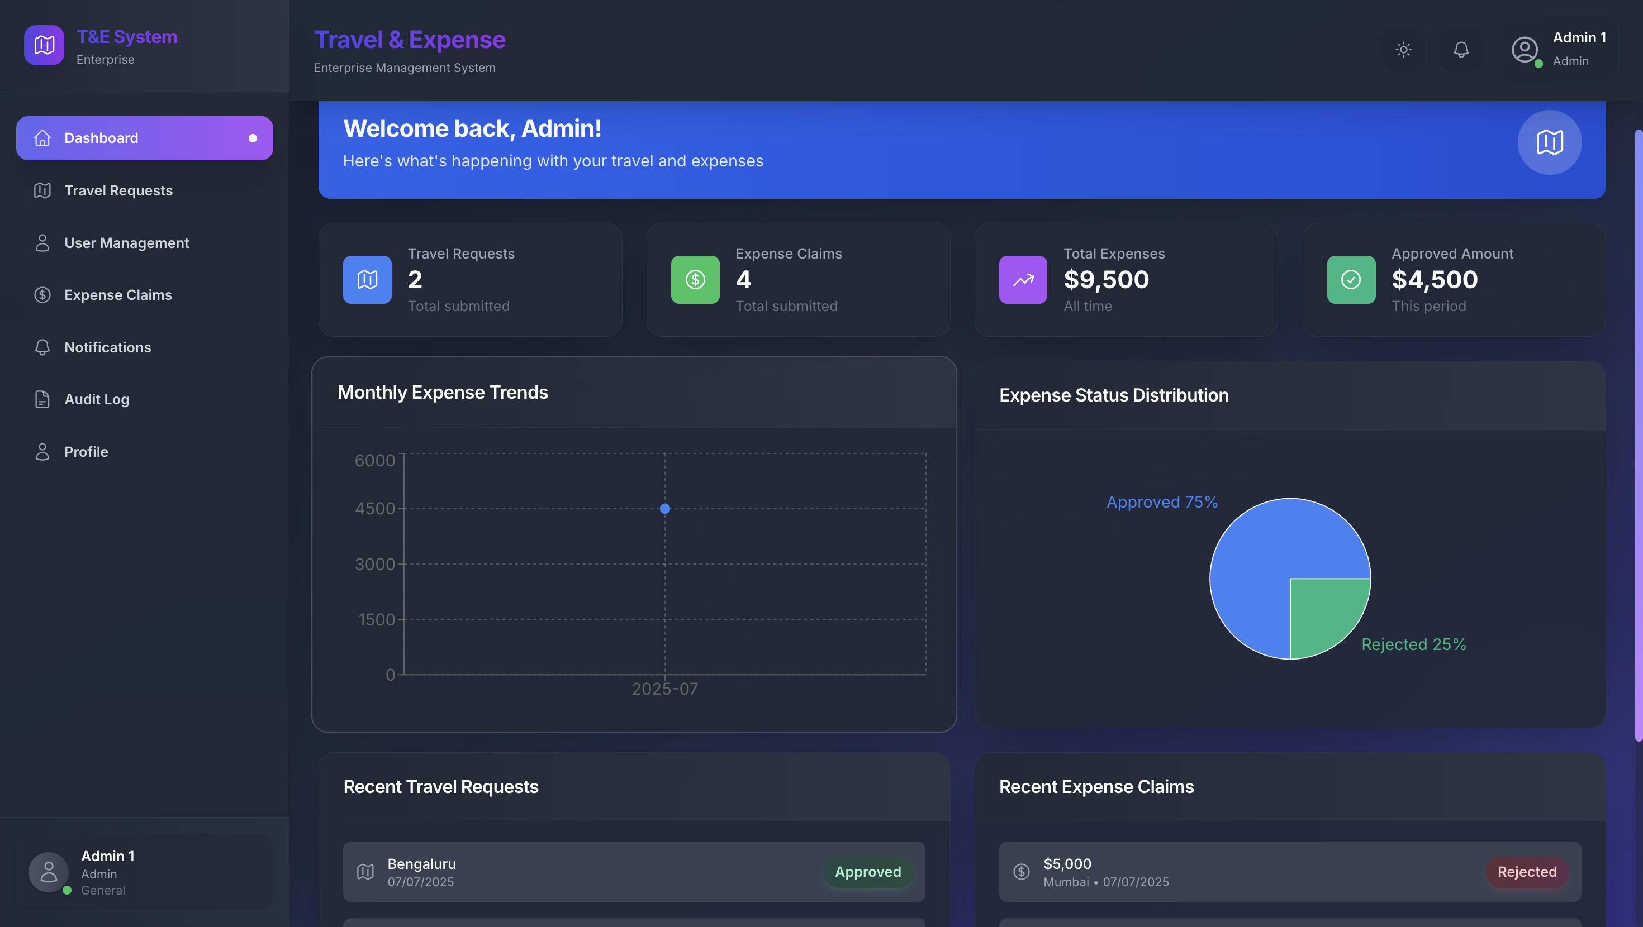

Admin Dashboard

*The Admin Dashboard provides a centralized interface for administrators to manage users, review requests, and monitor system activity. It features quick access to all core modules and real-time system status.*

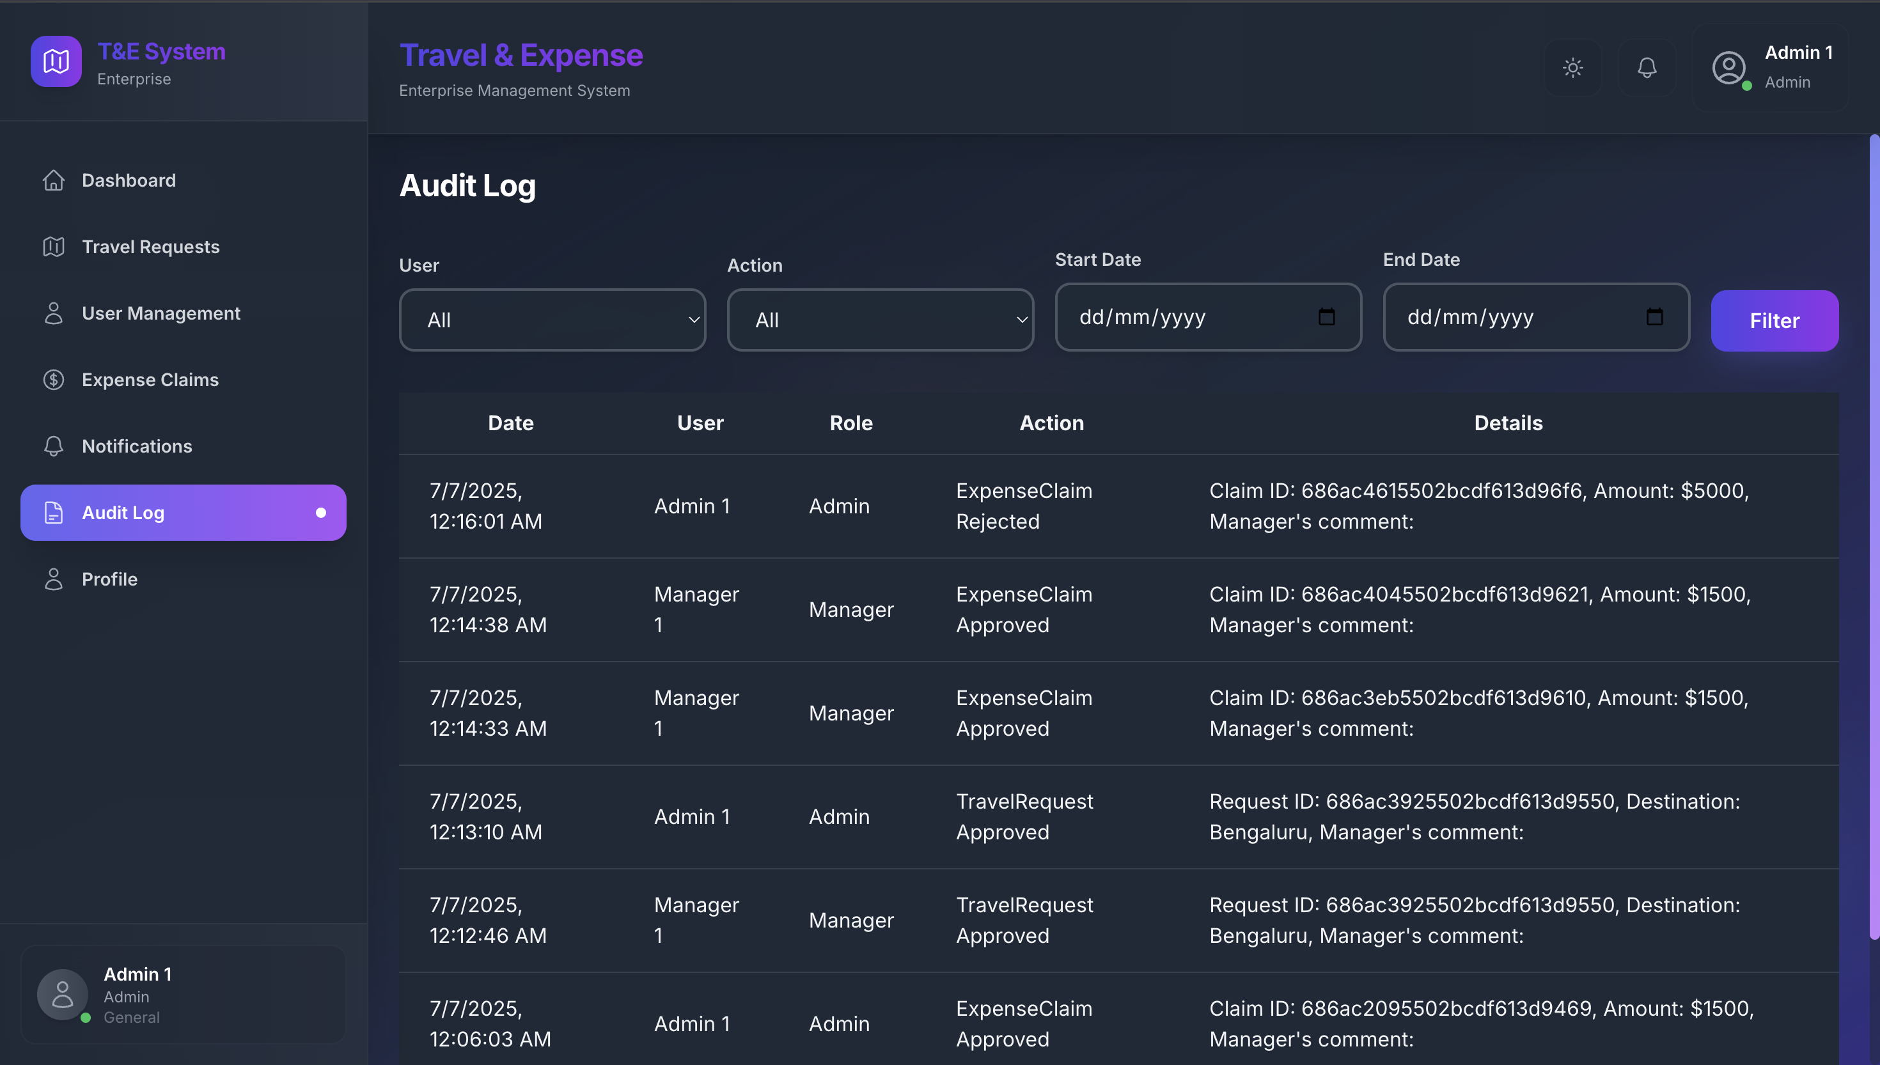

Audit Log

*The Audit Log records every significant action in the system, ensuring traceability and compliance. Admins can filter logs by user, action, or date for detailed investigations.*

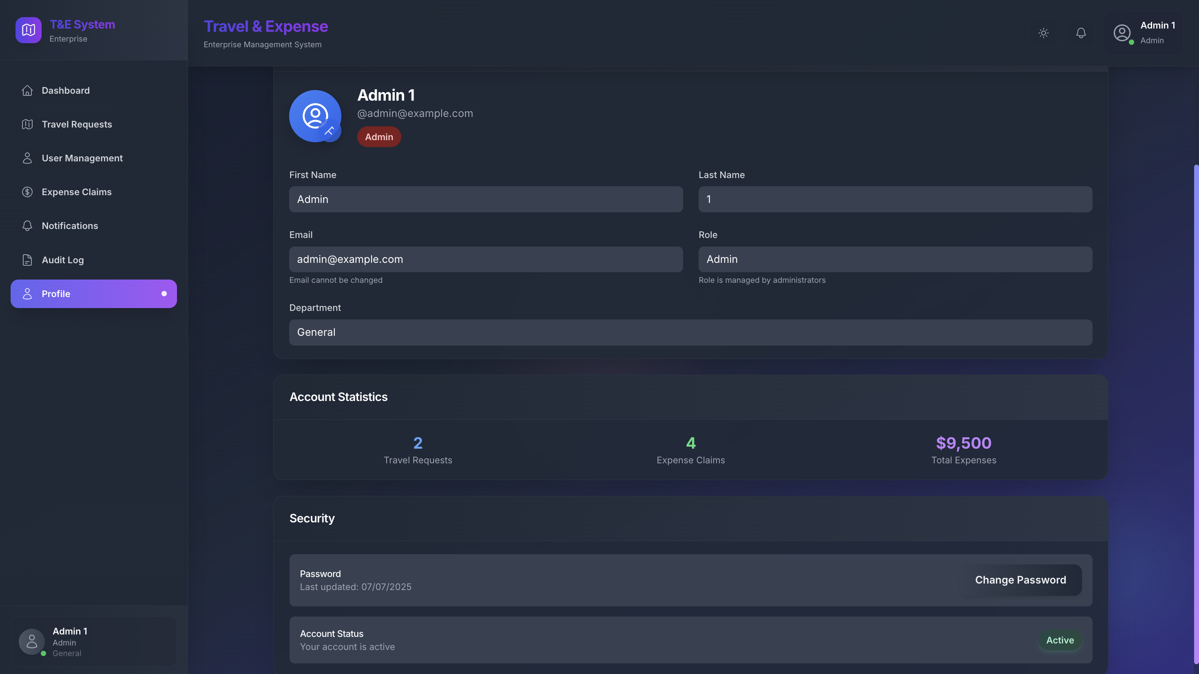

User Profile

*Each user has a modern, editable profile page displaying their role, department, and contact information. Users can update their details and manage their password securely.*

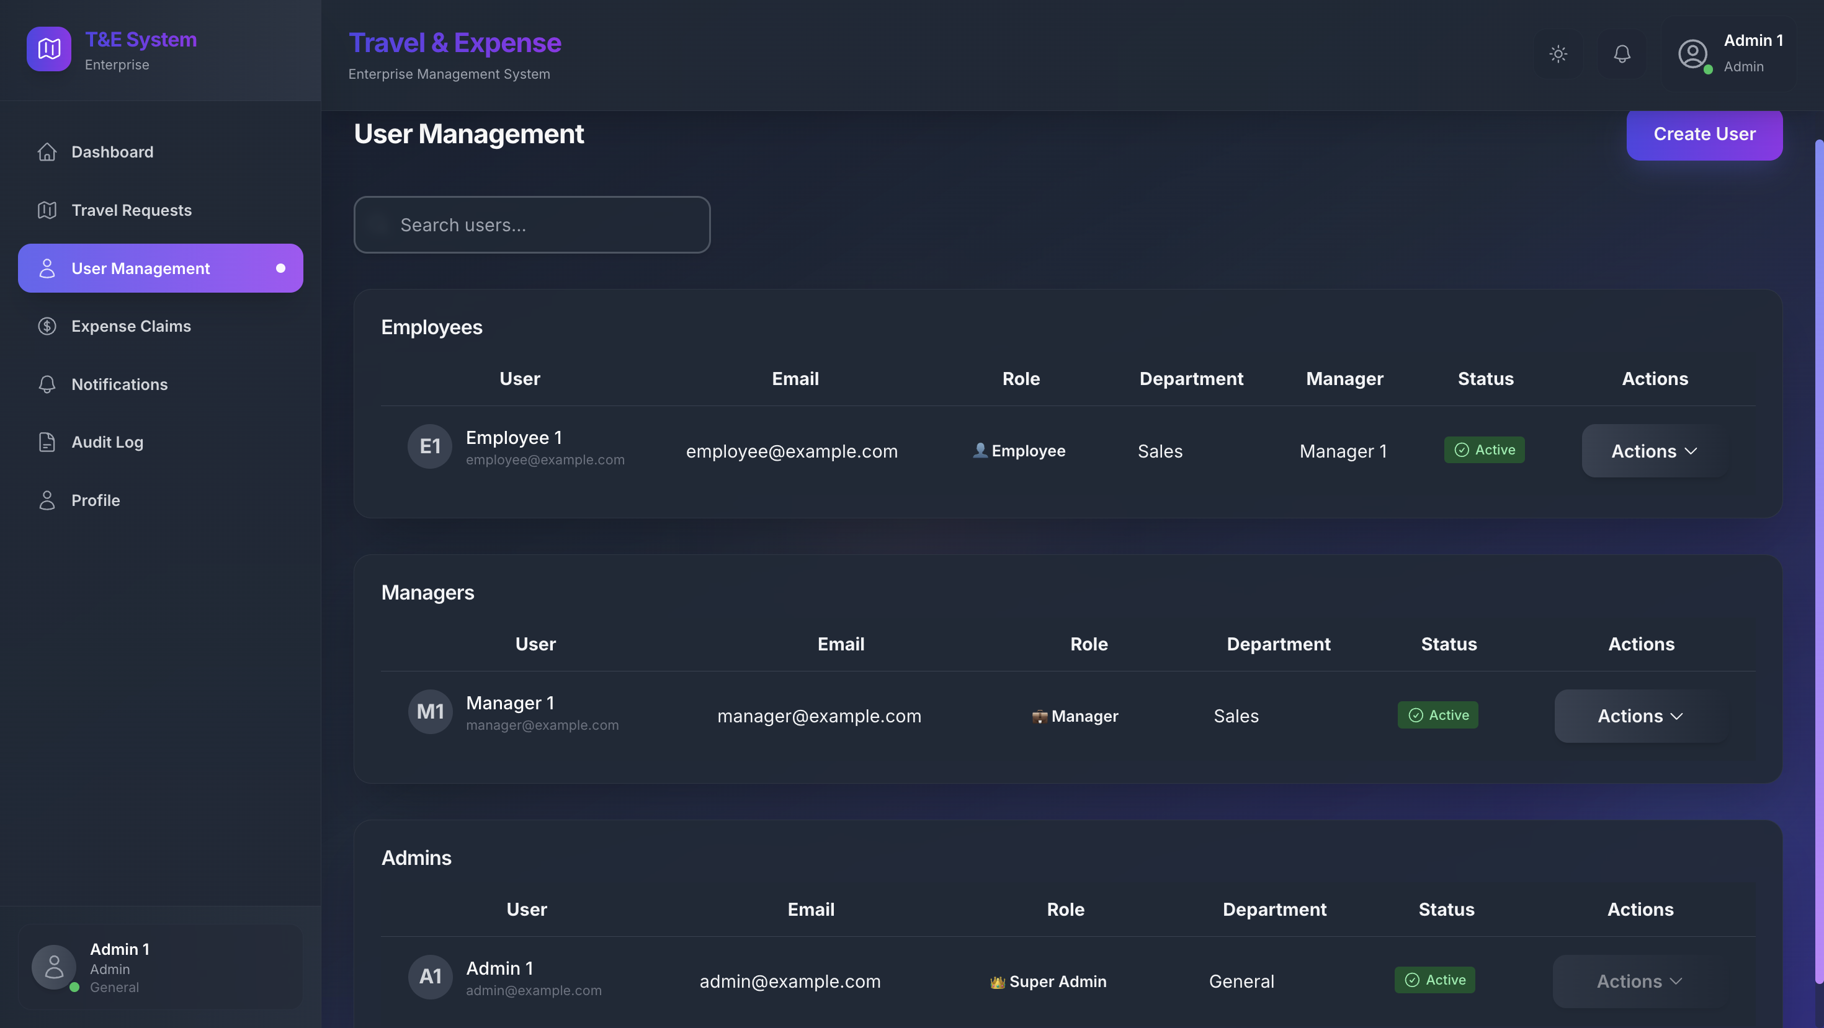

User Management

*Admins can activate, deactivate, or assign roles to users. The interface is designed for bulk actions and quick user lookup, supporting efficient enterprise management.*

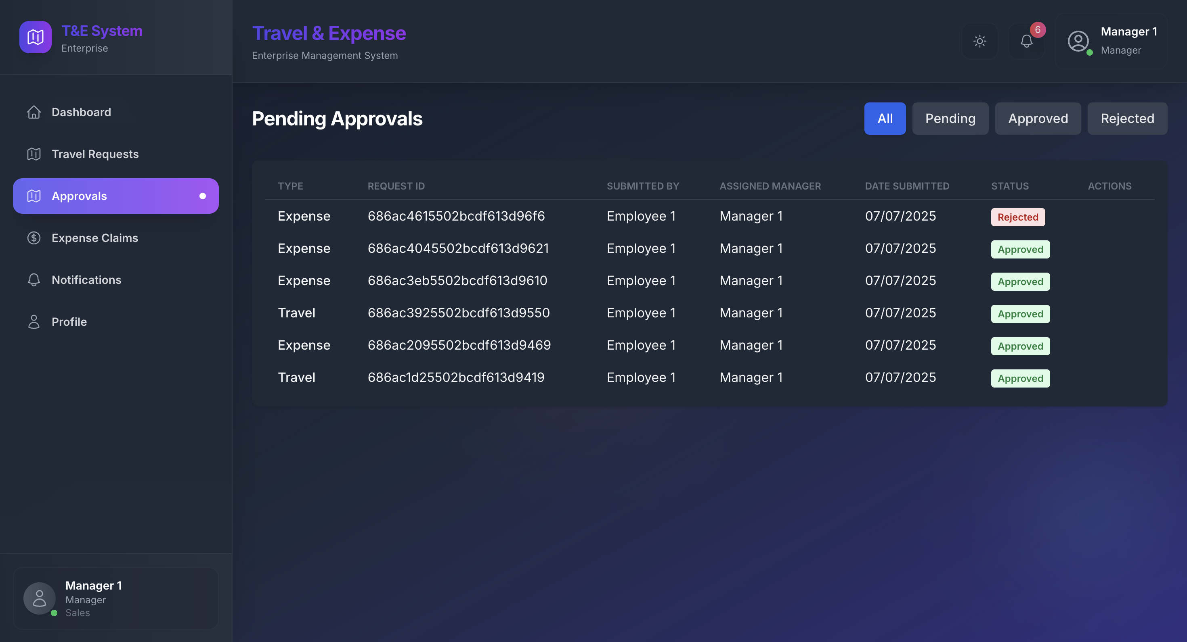

Approval Detail

*Managers and Admins can review, approve, or reject requests with full context, including attached documents and comments. The multi-level workflow is clearly visualized.*

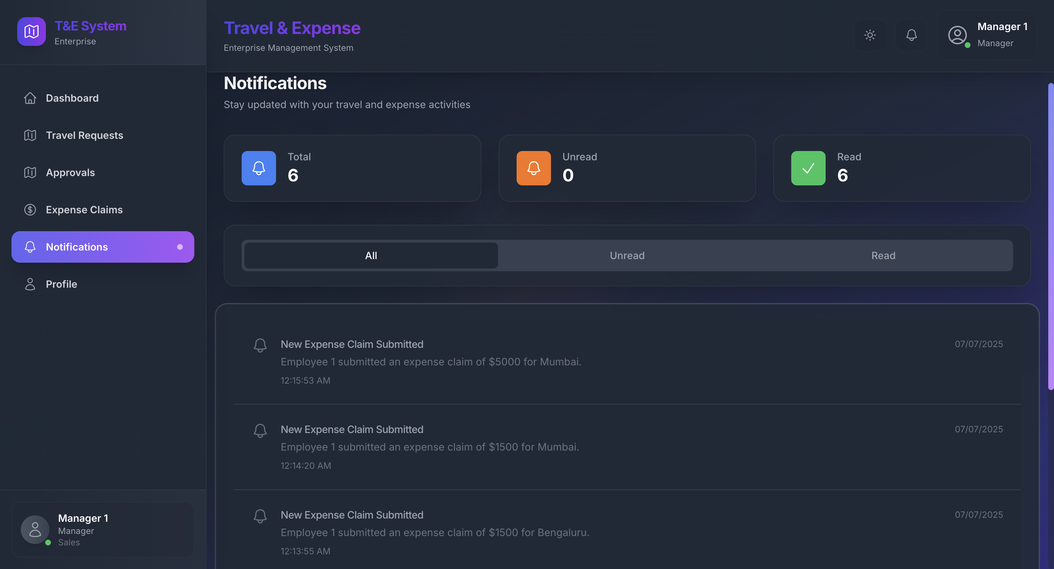

Notification Page

*All users receive real-time and email notifications for relevant actions. The notification center provides a history of alerts and their statuses.*

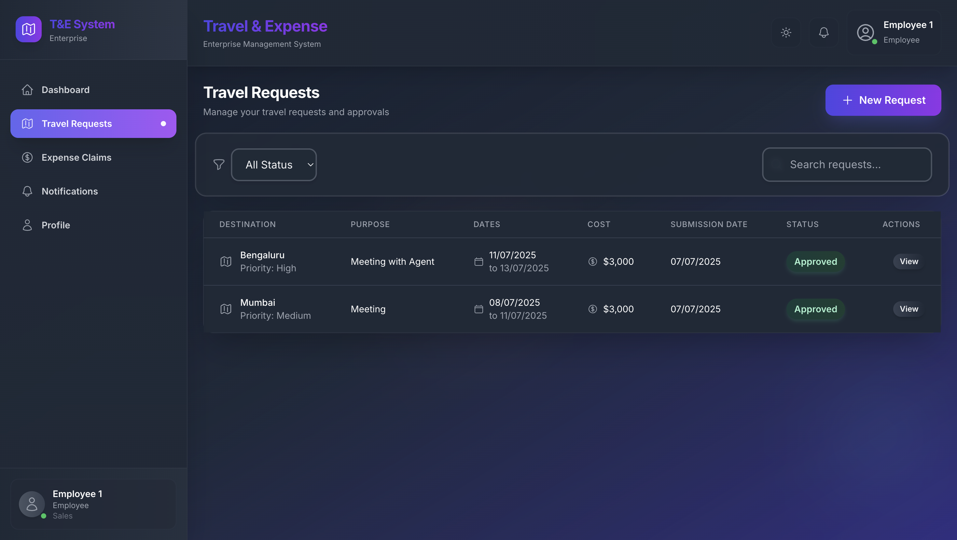

Travel Request List

*Employees can view and track the status of all their travel requests, with filters for date, status, and destination.*

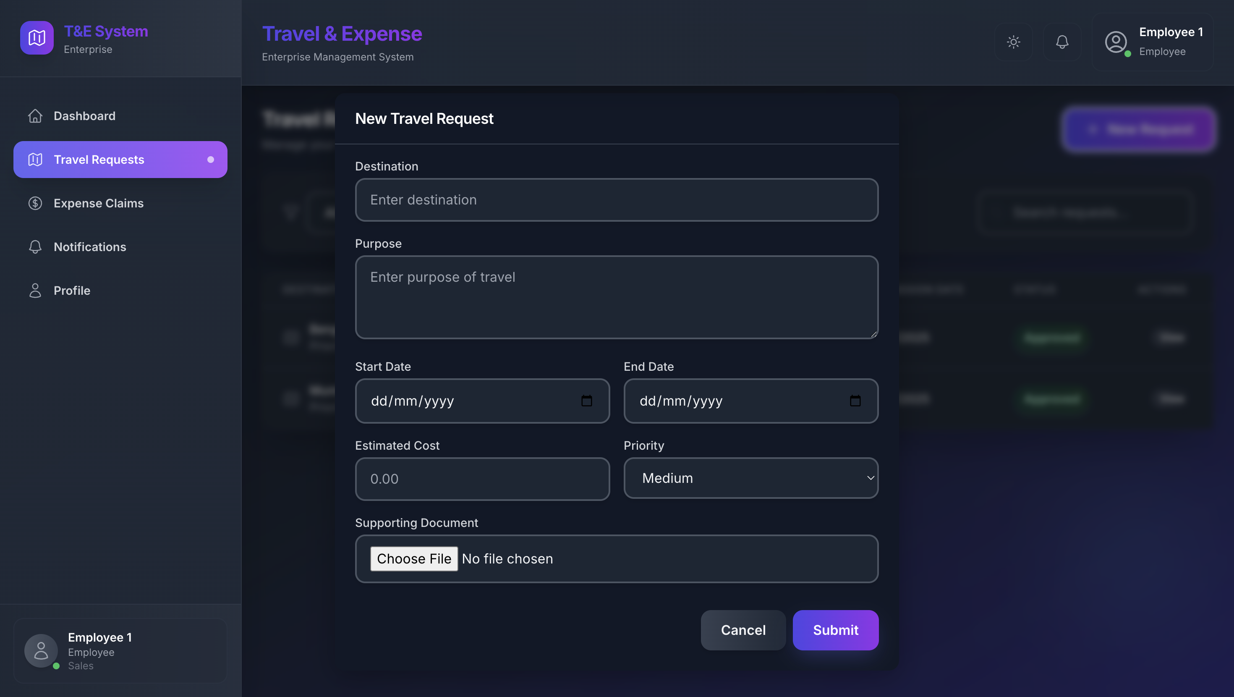

Travel Request Form

*A user-friendly form for submitting new travel requests, including date pickers, destination fields, and document upload functionality.*

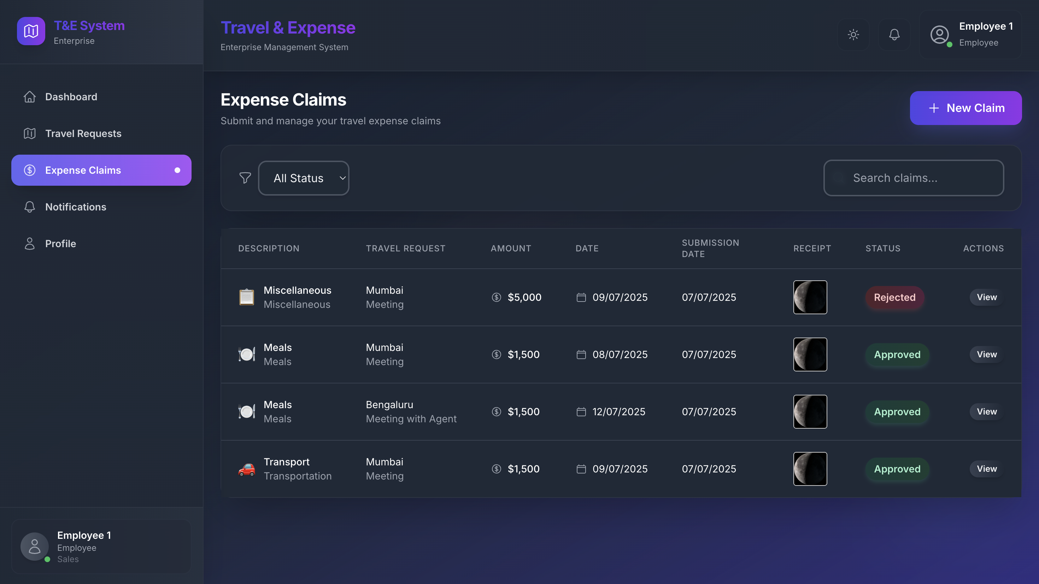

Expense Claim List

*A comprehensive list of all submitted expense claims, with status indicators and quick access to claim details.*

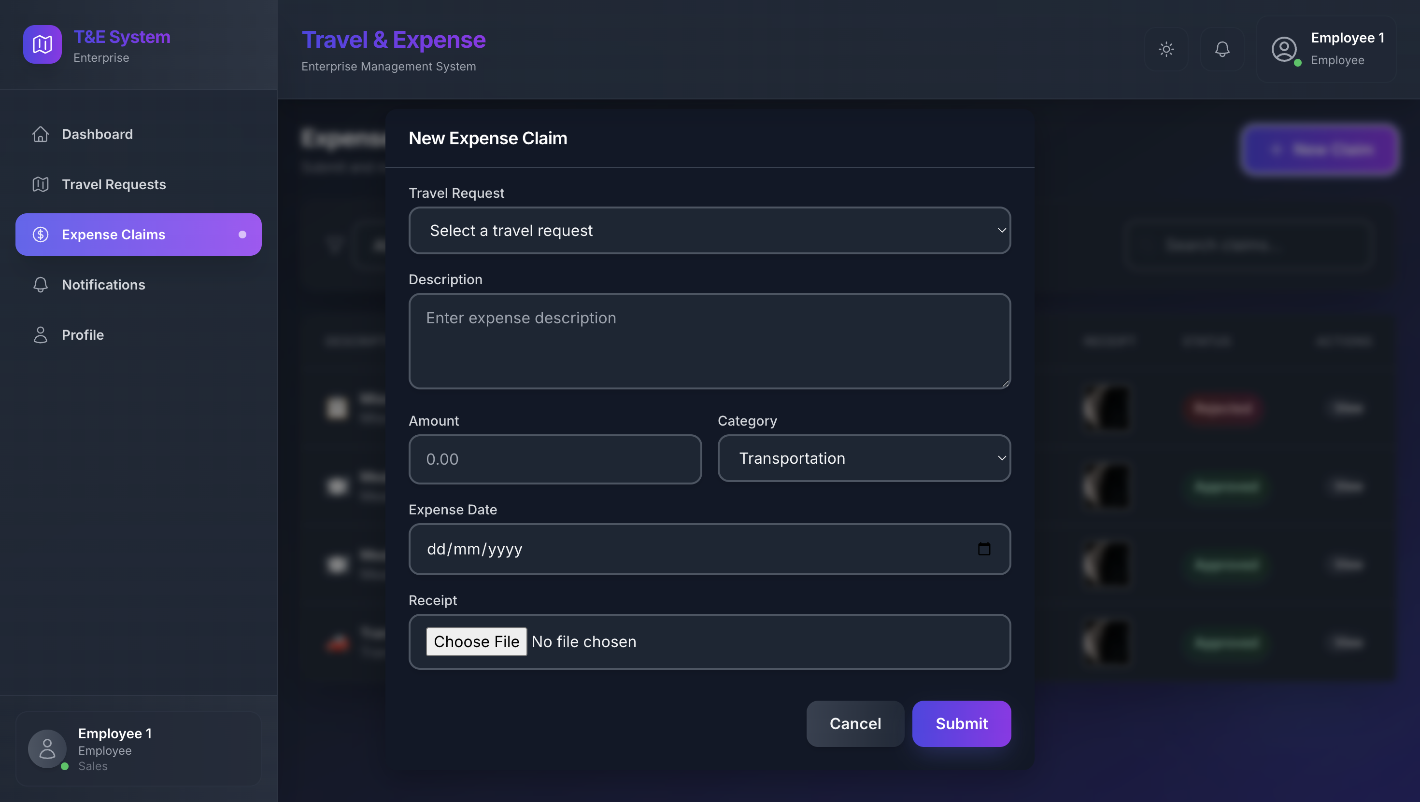

Expense Claim Form

*Employees can submit detailed expense claims, upload receipts, and categorize expenses for streamlined approval.*

# Challenges & Learnings

During development, several technical and logical challenges were addressed:

* Implementing secure, scalable authentication and authorization.
* Integrating real-time notifications with Socket.IO.
* Designing multi-level approval logic and preventing privilege escalation.
* Ensuring robust data validation and business rule enforcement.
* Handling file uploads securely and efficiently.
* Building a responsive, accessible UI with Tailwind CSS.

Key learnings included the importance of modular code structure, effective use of React Context for global state, balancing security with usability, and optimizing for both desktop and mobile experiences.

# Future Improvements

Planned enhancements for future versions include:

* Advanced analytics dashboards for spend analysis and KPIs.
* Native mobile app for on-the-go access.
* Customizable reports, PDF export, and scheduled email reports.
* Integration with HRMS, ERP, and accounting systems.
* AI/ML-powered fraud detection and smart approval suggestions.
* Internationalization for multi-language and multi-currency support.

# Conclusion

The Enterprise Travel & Expense Management System is a robust, secure, and scalable solution for modern organizations. It demonstrates best practices in full-stack development, security, and user experience, and is ready for real-world enterprise deployment.

# Contact & Support

[🗃️ GitHub](https://github.com/Kush-Varshney/) [👥 LinkedIn](https://www.linkedin.com/in/kush-varshney-490baa250/)

📂 [Project Repository](https://github.com/Kush-Varshney/Enterprise-Travel-Expense-System)

For further information, support, or collaboration inquiries, please contact: Kush Varshney (kushvarshney708@gmail.com) or connect via LinkedIn.

Thank you for reviewing this project documentation.